Arab Open University – Egypt



Faculty of Computer Studies
Information Technology and Computing Department

AI-Based Brain Tumor Classification from Magnetic Resonance Images

c Mohamed 21511545
TM471: Final Year Project, Oct 2025
Supervisor: Dr. Amira Abdelfatah

Abstract
Brain tumor detection from MRI is a demanding diagnostic task that requires expert interpretation and sustained attention. Recent advances in deep learning offer reliable tools to assist radiologists by improving consistency and reducing manual workload. This dissertation presents a convolutional neural network–based system for classifying 2D brain MRI images into four categories: Glioma, Meningioma, Pituitary tumor, and No tumor.
The project aims to develop a lightweight and explainable classification pipeline using a custom CNN and MobileNetV2 transfer learning. Visual explanations are provided using Grad-CAM to support interpretability.
The system was evaluated using standard classification metrics on a publicly available MRI dataset. The results demonstrate that efficient and interpretable classification of brain tumors is feasible using only 2D MRI slices, without relying on segmentation or volumetric data.

Acknowledgments
I begin by expressing my gratitude to Allah for guidance, patience, and perseverance throughout this journey.
I am deeply thankful to my mother for her constant support, understanding, and encouragement, which sustained me throughout this work.
I sincerely thank my supervisor, Dr. Amira Abdelfatah, for her guidance, constructive feedback, and continuous academic support, which were essential to the completion of this project.
I would like to thank my friends for their encouragement and support during the development of this dissertation.
Finally, I acknowledge the open-source research community and the contributors who made publicly available MRI datasets accessible for academic research.

Table of Contents
Abstract I
Acknowledgments II
Table of Contents III
Table of Figures V
Chapter 1: Introduction 1
1.1 Background 2
1.2 Dataset Context and Practical Constraints 2
1.3 Problem Statement 3
1.4 Project Aim 3
1.5 Project Objectives 4
1.6 Scope of the Project 5
1.7 Suggested Solution 6
1.8 Target Audience 6
1.9 Expected Contribution 7
1.10 Dissertation Structure 7
Chapter 2: Literature Review 8
2.1 Purpose and Structure of the Review 9
2.2 Brain Tumour MRI Analysis: Context and Challenges 9
2.3 From Classical Methods to Deep Learning in Brain MRI 10
2.4 Public MRI Datasets and Research Constraints 10
2.5 Explainability as a Requirement in Medical AI 11
2.6 Framing the Related Works 11
2.7 Related Works in Brain Tumour MRI Classification 12
2.7.1 2D MRI-Based Multi-Class Brain Tumour Classification 12
2.7.2 Lightweight and Transfer Learning Models Under Dataset Constraints 13
2.7.3 Explainable AI in Brain Tumour Classification 14
2.7.4 Segmentation-Based Approaches as a Contrast Case 14
2.8 Comparative Summary Table 15
2.9 Relationship Between Existing Work and This Project 16
2.10 Chapter Summary 17
Chapter 3: Requirements and Analysis 18
3.1 Chapter Overview 19
3.2 System Context and Assumptions 20
3.3 Functional Requirements 21
3.4 Non-Functional Requirements 22
3.5 Software and Hardware Requirements 23
3.6 System Decomposition and Analysis 24
3.7 UML Diagrams 25
3.7.1 Use Case Diagram 25
3.7.2 Activity Flow Diagram 26
3.7.3 Sequence Diagram 27
3.7.4 Class Diagram 28
3.7.5 Software Used to Generate UML Diagrams 28
3.8 Code of Ethics 29
3.9 Chapter Summary 30
References 31

Table of Figures
Figure 1 - Gantt Chart 6
Table 1 - Comparative Summary Table 15
Figure 2 - Use Case Diagram 25
Figure 3 - Activity Flow Diagram 26
Figure 4 - Sequence Diagram 27
Figure 5 - Class Diagram 28

Chapter 1: Introduction

1.1 Background
Brain tumors are serious neurological conditions where early and accurate diagnosis is essential for effective treatment. MRI is the primary imaging modality used, but manual interpretation is time-consuming and subject to variability, motivating the use of computer-aided diagnostic systems.
Recent advances in deep learning, particularly CNNs, have shown strong performance in medical image classification, including MRI-based tumor detection. However, most high-performing systems depend on large, fully annotated datasets that are rarely available for academic research.
This project operates within these constraints by focusing on brain tumor classification using publicly available 2D MRI slices, without segmentation masks or volumetric data, and prioritizes feasibility, explainability, and methodological clarity.

1.2 Dataset Context and Practical Constraints
The dataset used in this project consists exclusively of 2D MRI brain slices categorized into four classes: glioma, meningioma, pituitary tumor, and no tumor. Each image represents an isolated slice rather than a full 3D MRI volume. The dataset does not include tumor segmentation masks, bounding boxes, multi-sequence scans, or patient-level clinical metadata.
As a result, the dataset supports image-level classification only and does not enable tumor localization, volumetric analysis, growth tracking, or clinical decision support. These constraints directly influence the system design and necessitate a focus on technically valid and reproducible classification rather than advanced clinical modelling.

1.3 Problem Statement
Existing deep learning approaches to brain tumor analysis generally fall into two categories: classification systems that assign a tumor label to an image, and segmentation systems that identify precise tumor boundaries. While segmentation offers richer anatomical detail, it depends on pixel-level annotations and volumetric MRI data, neither of which is available in the dataset used for this project.
Furthermore, many classification-based systems function as black-box predictors, providing a tumor label without explaining the basis of the decision. In medical imaging research, this lack of interpretability limits trust and reduces the educational and experimental value of such systems.
The core problem addressed in this project is therefore defined as follows:
How can an accurate, interpretable, and computationally efficient deep learning system be designed to classify brain tumors using only 2D MRI images and class labels, under realistic academic dataset constraints?

1.4 Project Aim
The primary aim of this project is to design and evaluate an explainable deep learning–based system capable of classifying brain tumors from 2D MRI images. The system integrates visual explainability techniques to support interpretation of model decisions in the absence of segmentation data.
The project is intended as an academic and technical investigation rather than a clinical diagnostic tool.

1.5 Project Objectives
The objectives of this project are to:
- Prepare and preprocess a public 2D MRI dataset for classification.
- Design a CNN-based pipeline suitable for medical image analysis.
- Implement a task-specific custom CNN model.
- Apply MobileNetV2 as a lightweight transfer learning benchmark.
- Integrate Grad-CAM to generate visual explanations of model predictions.
- Evaluate model performance using standard classification metrics.
- Compare performance, efficiency, and interpretability between the two models.
- Analyze the capabilities and limitations of explainable classification without segmentation data.

1.6 Scope of the Project
This project includes:
- Image-level classification of 2D brain MRI slices.
- Four tumor classes only: glioma, meningioma, pituitary tumor, and no tumor.
- Supervised CNN-based learning.
- Explainability using Grad-CAM.
- Offline training and evaluation using a public dataset.
- Experimental comparison between two classification models.
This project explicitly excludes:
- Tumor segmentation or localization.
- 3D MRI or volumetric analysis.
- Clinical diagnosis or hospital deployment.
- Real-time systems or patient-specific decision support.
- Multi-sequence MRI fusion.
- Tumor progression or survival analysis.
These boundaries ensure that all claims remain scientifically valid and aligned with the available data.

1.7 Suggested Solution
This project proposes a classification-focused deep learning pipeline for constrained academic datasets, using CNN models trained on 2D MRI slices with integrated Grad-CAM explainability. A custom CNN is evaluated alongside MobileNetV2 to compare efficiency and performance, with explainability embedded as a core system component rather than a post-hoc feature.

1.8 Target Audience
The primary audience for this project includes undergraduate and postgraduate students, academic researchers, and educators in medical imaging and artificial intelligence. The system is designed to be reproducible, interpretable, and suitable for educational and experimental use rather than clinical deployment.

1.9 Project Planning

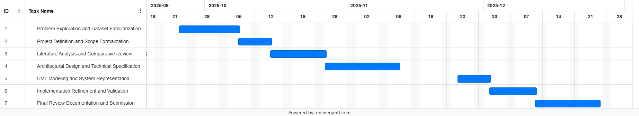
Figure 1 - Gantt Chart

1.9 Expected Contribution
The expected contributions of this project are:
- A complete and reproducible pipeline for brain tumor classification using 2D MRI images.
- A systematic comparison between a custom CNN and a lightweight transfer learning model.
- Integrated visual explainability using Grad-CAM.
- A realistic demonstration of the strengths and limitations of classification-based approaches under dataset constraints.
- A foundation for future academic extensions when richer data becomes available.

1.10 Dissertation Structure
This dissertation is structured as follows:
- Chapter 1 introduces the problem, scope, aims, and proposed solutions.
- Chapter 2 reviews related work in brain tumor classification and explainable medical AI.
- Chapter 3 presents system requirements and methodological design.
- Chapter 4 details implementation and experimental results.
- Chapter 5 concludes the study and outlines future research directions.

Chapter 2: Literature Review

2.1 Purpose and Structure of the Review
This chapter critically synthesizes existing research related to brain tumor analysis using deep learning, with a specific focus on MRI-based classification under constrained data conditions. Rather than presenting a broad survey of medical imaging research, the review is intentionally selective, and problem driven. Its purpose is to position the present project within the most relevant body of work, identify methodological patterns, and justify the design choices adopted.
The chapter is structured to give primary emphasis to related works in brain tumor MRI classification, reflecting their direct relevance. Supporting sections provide essential background on MRI imaging, machine learning paradigms, and explainable AI only insofar as they inform the comparison and synthesis of related studies. Segmentation-based research is discussed mainly as a contrast case, illustrating why such approaches are unsuitable for the dataset used in this project.

2.2 Brain Tumor MRI Analysis: Context and Challenges
Brain tumor diagnosis is a complex clinical task due to the heterogeneity of tumor types, anatomical variability, and ambiguity in imaging appearance. Gliomas, meningiomas, and pituitary tumors differ significantly in biological behavior, yet their visual characteristics on MRI often overlap, especially when examined on individual slices rather than full volumetric scans.
Magnetic Resonance Imaging is the dominant modality for brain tumor assessment due to its high soft tissue contrast and flexibility. However, MRI interpretation is cognitively demanding and subject to inter-observer variability. These challenges have motivated extensive research into automated image analysis systems that can support clinicians by improving consistency and reducing diagnostic workload.
From a computational perspective, MRI data presents additional challenges, including intensity non-uniformity, scanner variability, noise, and limited standardization across datasets. These issues directly influence the choice of paradigm and model architecture in academic research.

2.3 From Classical Methods to Deep Learning in Brain MRI
Early computational approaches to brain tumor classification relied on handcrafted features combined with traditional classifiers. While these methods provided early insights, their dependence on manual feature design limited their robustness and generalizability.
The introduction of convolutional neural networks transformed medical image analysis by enabling end-to-end learning directly from pixel data. CNNs have since become the dominant approach for MRI-based classification, segmentation, and detection tasks. However, their success depends heavily on data availability, which remains a critical limitation in medical research.
As a result, a substantial portion of the literature focuses on 2D slice-based classification using public datasets, rather than clinically comprehensive volumetric analysis. This research direction is not a simplification for convenience, but rather a pragmatic response to real data constraints.

2.4 Public MRI Datasets and Research Constraints
Publicly available brain MRI datasets typically consist of 2D slices labeled at the image level, often grouped into tumor categories such as glioma, meningioma, pituitary tumor, and non-tumorous images. These datasets rarely include segmentation masks, 3D continuity, or patient-level clinical metadata.
While such datasets limit the scope of feasible tasks, they have enabled a large body of reproducible academic research. The literature shows that meaningful classification performance can be achieved when models are carefully designed to match dataset characteristics. Consequently, many recent studies emphasize feasibility, efficiency, and robustness rather than clinical completeness.

2.5 Explainability as a Requirement in Medical AI
A recurring concern in medical deep learning research is the opacity of CNN-based models. High accuracy alone is insufficient in healthcare contexts, where trust, accountability, and error analysis are essential.
Explainable AI methods aim to address this issue by making model decisions interpretable. In image classification tasks, gradient-based visualization techniques—most notably Grad-CAM—have become standard due to their simplicity and compatibility with CNN architectures. Explainability is particularly important in classification-only systems, where no explicit spatial output (such as segmentation masks) is available.

2.6 Framing the Related Works
Against this background, existing research in brain tumor analysis can be broadly divided into two methodological categories:
- MRI-based tumor classification using 2D slices, and
- MRI-based tumor segmentation using volumetric data.
Given the absence of segmentation masks and 3D MRI volumes in the dataset used for this project, the following sections emphasize classification-oriented studies, while segmentation-based works are discussed mainly to justify their exclusion.

2.7 Related Works in Brain Tumor MRI Classification

2.7.1 2D MRI-Based Multi-Class Brain Tumor Classification
A growing body of literature demonstrates that accurate brain tumor classification is achievable using 2D MRI slices and image-level labels alone, without relying on volumetric data or pixel-level annotations.
Haque et al. (2024) proposed NeuroNet19, an explainable deep learning architecture for four-class brain tumor classification, including glioma, meningioma, pituitary tumor, and no tumor. Built on a VGG19 backbone with an Inverted Pyramid Pooling Module, the model captures multi-scale features from 2D slices. The study reports classification accuracy exceeding 99% on a large public dataset and integrates LIME to provide visual explanations. This work demonstrates that high performance is achievable with slice-based data, while also highlighting the increasing expectation of interpretability in medical AI systems.
Reyes and Sánchez (2024) adopted a comparative perspective, evaluating custom CNNs alongside multiple transfer learning architectures such as VGG, ResNet, EfficientNet, and MobileNet. Their results show that lightweight models, particularly MobileNet, achieve competitive accuracy while offering substantial gains in training speed and computational efficiency. This study challenges the assumption that deeper or more complex models are inherently superior, especially under public dataset constraints.
Almusharraf et al. (2024) further reinforce these findings through a sequential CNN designed for four-class classification using 2D MRI slices. The integration of Grad-CAM enables visual inspection of model attention, directly addressing concerns about black-box behavior. The authors explicitly discuss dataset limitations and overfitting risks, framing their model as a realistic academic solution rather than a clinical system.
Synthesis:
Across these studies, several consistent conclusions emerge:
- Multi-class brain tumor classification is feasible using 2D MRI slices.
- High performance does not require volumetric data when models are appropriately designed.
- Interpretability is increasingly treated as a necessary component rather than an optional enhancement.
These conclusions directly support the design choices of the present project.

2.7.2 Lightweight and Transfer Learning Models Under Dataset Constraints
Another dominant theme in recent literature is the use of lightweight architecture and transfer learning to address limited data availability and hardware constraints.
Vimala et al. (2023) evaluated EfficientNet variants (B0–B4) on 2D MRI brain tumor classification tasks using the Figshare dataset. Despite the reduced parameter count of these models, the authors report strong classification performance and successfully integrate Grad-CAM for interpretability. Although limited to three tumor classes, the study demonstrates that efficiency and explainability can coexist.
Rasa et al. (2024) conducted a comprehensive evaluation of six transfer learning models, including MobileNetV2, VGG16, ResNet50, DenseNet201, and EfficientNetB3. Their results show that MobileNetV2 offers an effective balance between accuracy and computational efficiency, particularly when combined with data augmentation and cross-validation. This finding is especially relevant for academic environments with limited hardware resources.
Nazir et al. (2024) proposed a custom CNN combined with multiple explainability techniques, including Grad-CAM, SHAP, and LIME. Although focused on binary classification, the study underscores the importance of transparency and demonstrates that explainability can be layered onto lightweight architectures without architectural complexity.
Synthesis:
The literature consistently indicates that:
- Lightweight models are well-suited to public MRI datasets.
- Transfer learning mitigates data scarcity and stabilizes training.
- Computational efficiency is increasingly framed as a research objective rather than a compromise.
This aligns closely with the methodological priorities of the present project.

2.7.3 Explainable AI in Brain Tumor Classification
Explainability has emerged as a central concern in medical AI research, particularly for classification systems that lack explicit spatial outputs.
Grad-CAM is the most widely adopted explainability technique in the reviewed literature. Studies by Almusharraf et al. (2024) and Nazir et al. (2024) demonstrate that Grad-CAM heatmaps improve confidence in model behavior and help identify spurious correlations. Haque et al. (2024) employ LIME as an alternative, offering class-discriminative explanations through perturbation analysis, though at higher computational cost.
Across studies, Grad-CAM is favored due to its low overhead, architectural compatibility, and intuitive visual output. However, many works still treat explainability as a supplementary step rather than a core design constraint.
The present project differs by integrating Grad-CAM as a fundamental component of the system pipeline, not merely as an evaluation tool.

2.7.4 Segmentation-Based Approaches as a Contrast Case
Segmentation-based models represent the dominant paradigm in clinical brain tumor research, offering pixel-level delineation and volumetric analysis. Khan et al. (2024) proposed an attention-based U-Net achieving high Dice scores, while Wang et al. (2024) introduced LATUP-Net, a lightweight 3D segmentation architecture.
Despite their technical sophistication, these approaches assume the availability of pixel-level annotations and full 3D MRI volumes. Such assumptions are incompatible with public, class-labeled datasets, making these models unsuitable for the present project.
Their inclusion in this review serves to justify the classification-based approach rather than to propose alternatives.

2.8 Comparative Summary Table
Work | Task | Data Type | Model Strategy | Explainability | Key Insight
Haque et al. (2024) | Classification | 2D MRI | VGG19-based CNN | LIME | High accuracy achievable with slice-based data
Reyes & Sánchez (2024) | Classification | 2D MRI | CNN + transfer learning | None | Lightweight models rival deep architectures
Almusharraf et al. (2024) | Classification | 2D MRI | Custom CNN | Grad-CAM | Explainability improves trust under constraints
Vimala et al. (2023) | Classification | 2D MRI | EfficientNet | Grad-CAM | Efficiency and performance can coexist
Rasa et al. (2024) | Classification | 2D MRI | MobileNetV2 et al. | None | MobileNetV2 balances accuracy and efficiency
Nazir et al. (2024) | Classification | 2D MRI | Custom CNN | Grad-CAM, SHAP, LIME | Transparency is critical even for simple tasks
Segmentation Studies | Segmentation | 3D MRI + masks | U-Net variants | Limited | Data assumptions unsuitable for public datasets
Present Project | Classification | 2D MRI | Custom CNN + MobileNetV2 | Grad-CAM (integrated) | Constraint-aware, explainable, reproducible

Table 1 - Comparative Summary Table

2.9 Relationship Between Existing Work and This Project
The reviewed literature provides a clear basis for positioning this project within current research on brain tumor MRI analysis. Prior studies show that deep learning–based classification using 2D MRI slices is both feasible and effective when segmentation masks or full volumetric data are unavailable, which aligns directly with the constraints of the dataset used in this project.
While many existing works report high classification accuracy, they often prioritize benchmark performance with limited attention to interpretability, computational feasibility, or reproducibility. In contrast, this project treats these factors as core design requirements, recognizing that accuracy alone is insufficient in constrained academic settings.
The literature also indicates that lightweight and transfer learning–based models, such as MobileNet and EfficientNet, can achieve performance comparable to heavier architectures on public MRI datasets. This supports the project’s decision to compare a custom CNN with MobileNetV2 to evaluate trade-offs between efficiency, simplicity, and performance rather than to pursue architectural novelty.
Explainability further distinguishes this work. Although techniques such as Grad-CAM are commonly used, they are often applied only as post-hoc visualizations. This project integrates Grad-CAM directly into the evaluation pipeline to assess model attention and plausibility in the absence of segmentation data.
Finally, segmentation-focused studies reinforce—rather than undermine—the classification-based scope adopted here. While segmentation offers richer anatomical detail, it depends on assumptions that are unrealistic for most public datasets. By adopting a constraint-aware and methodologically transparent approach, this project addresses key gaps in feasibility, interpretability, and reproducibility identified in the existing literature.

2.10 Chapter Summary
This chapter synthesized existing research on MRI-based brain tumor analysis, with a focused emphasis on deep learning classification under realistic data and resource constraints. The review showed how the reliance on public datasets has driven research toward 2D slice-based classification rather than volumetric or segmentation-based approaches.
The literature demonstrates that accurate multi-class classification is achievable using 2D MRI slices and image-level labels, particularly when lightweight architectures and transfer learning are employed to balance performance and computational feasibility. It also highlights the growing importance of explainable AI, noting that methods such as Grad-CAM are often treated as secondary rather than integral components.
Segmentation-based approaches were examined as a contrast, illustrating their dependence on pixel-level annotations and 3D MRI data, which are incompatible with public datasets. Overall, the reviewed studies strongly support the methodological choices of this project, validating its focus on 2D classification, efficiency, and integrated explainability as a sound and reproducible research direction.

Chapter 3: Requirements and Analysis

3.1 Chapter Overview
This chapter analyzes the proposed system and defines the functional and non-functional requirements needed to achieve the project objectives. As the project is academic and experimental, the analysis prioritizes feasibility, interpretability, and reproducibility, using UML diagrams to model system structure and behavior while addressing ethical considerations and dataset constraints.

3.2 System Context and Assumptions
The system is designed as a lightweight, mobile-oriented experimental application supported by an offline-trained deep learning model. Its purpose is to allow users to upload a single 2D brain MRI image and receive a predicted tumor class accompanied by a visual explanation.
The system operates under the following assumptions:
- Input data consists exclusively of valid 2D brain MRI slices.
- Images are labeled only at the image level, with no segmentation or volumetric data.
- Users are non-clinical stakeholders, such as students or researchers.
- Training and evaluation are performed offline in a controlled environment.
- The system does not provide medical diagnosis or clinical decision support.

3.3 Functional Requirements
The system shall:
- Accept individual 2D brain MRI images in standard formats (e.g., PNG, JPEG).
- Preprocess input images using resizing, normalization, and grayscale handling where applicable.
- Classify each MRI image into one of four categories: glioma, meningioma, pituitary tumor, or no tumor.
- Support classification using two models: a custom CNN and a MobileNetV2-based transfer learning model.
- Generate class-specific visual explanations using Grad-CAM.
- Produce combined image–heatmap overlays for interpretability.
- Display prediction results, including class label and confidence score.
- Compute evaluation metrics including accuracy, precision, recall, F1-score, and confusion matrices.

3.4 Non-Functional Requirements
- Interpretability:
The system shall provide explainable outputs using integrated Grad-CAM visualization.
- Efficiency:
The system shall operate within computational limits suitable for academic hardware.
- Reliability:
The system shall produce consistent results for identical inputs and configurations.
- Reproducibility:
Fixed dataset splits, preprocessing steps, and training settings shall be used.
- Maintainability:
The system shall follow a modular design separating preprocessing, modeling, explainability, and evaluation.
- Ethical Compliance:
The system shall operate only on de-identified, publicly available data.
- Portability:
The design shall support deployment within lightweight desktop or mobile interfaces.

3.5 Software and Hardware Requirements
Software Requirements
- Python programming language
- Deep learning frameworks (TensorFlow or PyTorch)
- OpenCV and NumPy for image preprocessing
- Scikit-learn for evaluation metrics
- Grad-CAM implementation libraries
- Diagramming software for UML modeling
Hardware Requirements
- Standard personal computer or laptop
- CPU with multi-core support
- Optional GPU acceleration for training
- Minimum 8 GB RAM
- No specialized medical or clinical hardware required

3.6 System Decomposition and Analysis
The system is decomposed into the following stages:
- Dataset loading and inspection
- Image preprocessing
- Model configuration and selection
- Training and validation
- Explainability generation
- Performance evaluation
This decomposition allows each stage to be developed, tested, and validated independently.

3.7 UML Diagrams
This section presents the UML diagrams used to model the structure, behavior, and interactions of the proposed system. Each diagram captures a distinct perspective of system functionality and collectively provides a complete representation of the system design.

3.7.1 Use Case Diagram
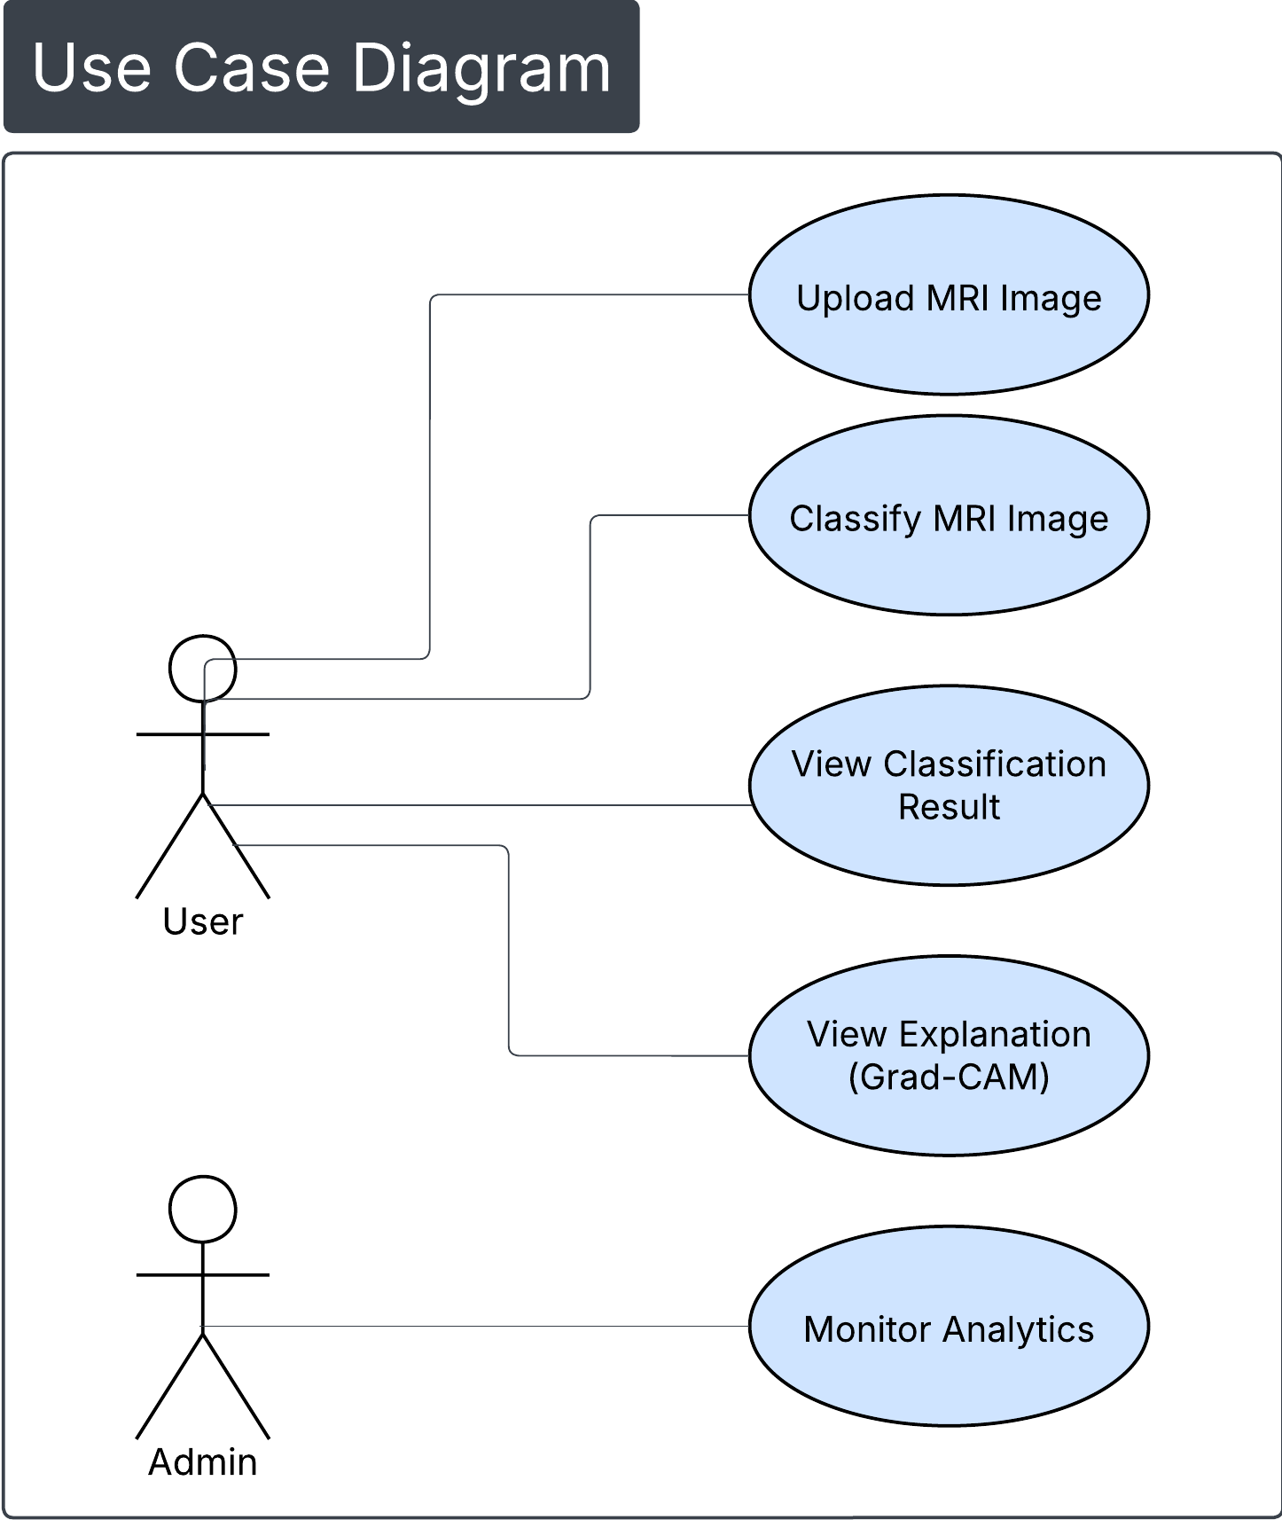
The diagram shows how the user interacts with the system to upload an MRI image, classify it, and view the classification result and Grad-CAM explanation, with an additional option to monitor system analytics.
Figure 2 - Use Case Diagram

3.7.2 Activity Flow Diagram
The activity flow shows how the system validates an uploaded MRI image, processes valid inputs for classification and Grad-CAM generation and handles invalid inputs by requesting a new upload.
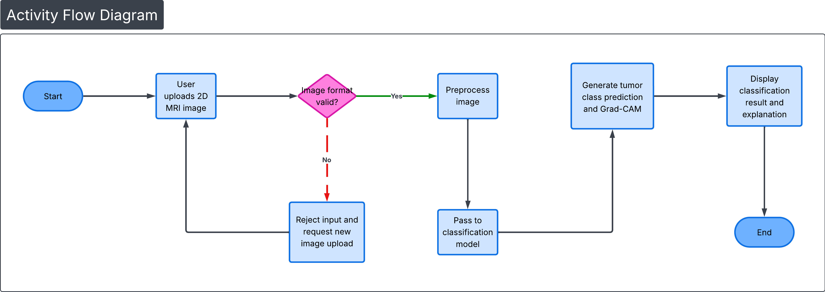
Figure 3 - Activity Flow Diagram

3.7.3 Sequence Diagram
The sequence diagram illustrates how a user uploads an MRI image, which is validated and processed by the system, classified by the model, and returned with prediction and Grad-CAM results for display.
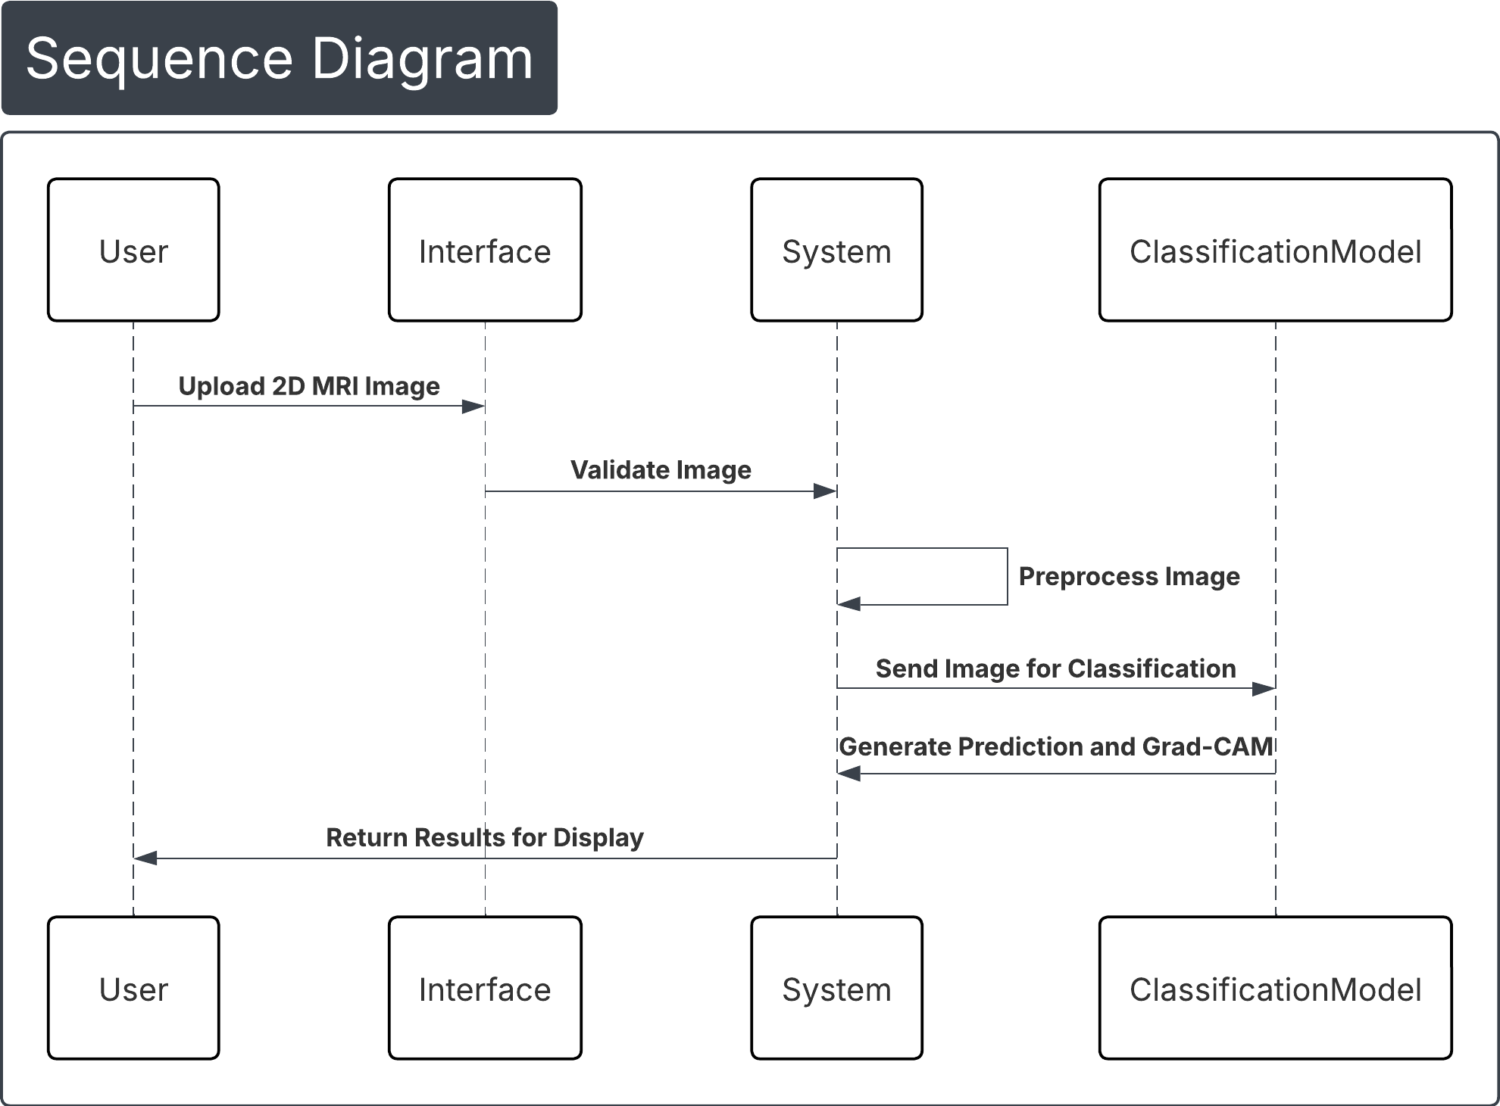
Figure 4 - Sequence Diagram

3.7.4 Class Diagram
The class diagram shows the core system components responsible for image upload, preprocessing, classification, and result generation, and the relationships between them within the image classification system.
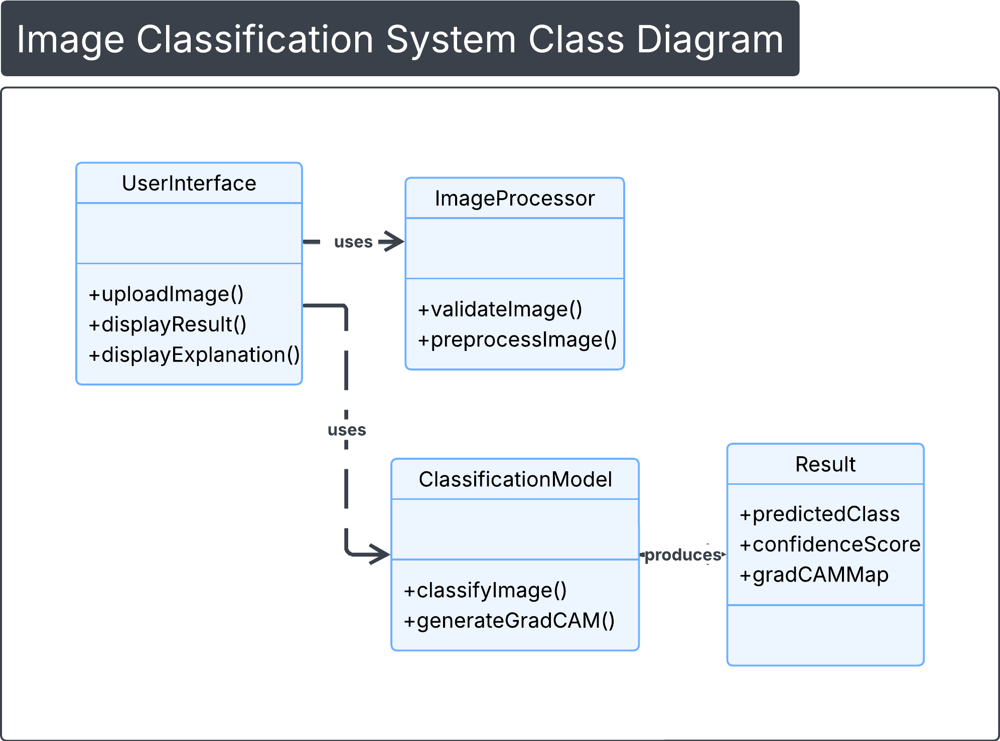
Figure 5 - Class Diagram

3.7.5 Software Used to Generate UML Diagrams
All UML and system diagrams were created using Lucidchart, ensuring clear representation.

3.8 Code of Ethics
This project adheres to established ethical standards in computing and medical AI, including principles outlined in the ACM Code of Ethics.
- Only publicly available, de-identified MRI datasets are used.
- No patient-identifiable or clinical data is collected or stored.
- The system is explicitly non-diagnostic and assistive in nature.
- Outputs are presented for educational and experimental purposes only.
- System limitations and dataset constraints are clearly documented to avoid misleading claims.

3.9 Chapter Summary
This chapter translated project objectives into explicit functional and non-functional requirements, defined software and hardware needs, and modeled system behavior using UML diagrams. The classification-based approach was justified through dataset-aware analysis, and ethical considerations were integrated into the system design. Together, these elements provide a clear and reproducible foundation for the implementation and experimental evaluation presented in the following chapters.

References
Almusharraf, A.I., Alshuhail, A., Thakur, A., Alqahtani, A., Alqahtani, S. and Alotaibi, F. (2024) ‘Refining neural network algorithms for accurate brain tumor classification in MRI imagery’, BMC Medical Imaging, 24, pp. 1–15.
Haque, R., Hassan, M., Bairagi, A.K. and Islam, S.S. (2024) ‘NeuroNet19: an explainable deep neural network model for the classification of brain tumors using magnetic resonance imaging data’, Scientific Reports, 14, pp. 1–17.
Howard, A.G., Sandler, M., Chu, G., Chen, L.-C., Chen, B., Tan, M., Wang, W., Zhu, Y., Pang, R., Vasudevan, V., Le, Q.V. and Adam, H. (2018) ‘MobileNetV2: inverted residuals and linear bottlenecks’, in Proceedings of the IEEE Conference on Computer Vision and Pattern Recognition (CVPR). Salt Lake City, UT: IEEE, pp. 4510–4520.
Kaggle (2025) BRISC2025: Brain MRI for Brain Tumor Classification. Available at: https://www.kaggle.com/datasets/briscdataset/brisc2025 (Accessed: 10 March 2025).
Nazir, M.I., Akter, A., Wadud, M.A.H. and Uddin, M.A. (2024) ‘Utilizing customized CNN for brain tumor prediction with explainable artificial intelligence’, Heliyon, 10, pp. 1–15.
Reyes, D. and Sánchez, J. (2024) ‘Performance of convolutional neural networks for the classification of brain tumors using magnetic resonance imaging’, Heliyon, 10, pp. 1–14.
Rasa, S.M., Islam, M.M., Talukder, M.A., Rahman, M.S. and Hossain, M.S. (2024) ‘Brain tumor classification using fine-tuned transfer learning models on magnetic resonance imaging (MRI) images’, Digital Health, 10, pp. 1–14.
Selvaraju, R.R., Cogswell, M., Das, A., Vedantam, R., Parikh, D. and Batra, D. (2017) ‘Grad-CAM: visual explanations from deep networks via gradient-based localization’, in Proceedings of the IEEE International Conference on Computer Vision (ICCV). Venice, Italy: IEEE, pp. 618–626.
Vimala, B.B., Srinivasan, S., Mathivanan, S., Rajesh, R. and Kumar, P.S. (2023) ‘Detection and classification of brain tumor using hybrid deep learning models’, Scientific Reports, 13, pp. 1–16.
Wang, X., Zhang, Y., Liu, J. and Zhou, Z. (2024) ‘LATUP-Net: a lightweight 3D attention U-Net with parallel convolutions for brain tumor segmentation’, Computers in Biology and Medicine, 168, 107633.

